**DATA VISUALIZATION USING PYTHON**

A COURSE PROJECT REPORT

By

UTKARSH SINHA (RA1911003010521)

*In partial fulfilment for the Course*

of

18CSE301J– INFORMATION VISUALIZATION

in

Data Science and Business Systems



**FACULTY OF ENGINEERING AND TECHNOLOGY**

**SRM INSTITUTE OF SCIENCE AND TECHNOLOGY**

**Kattankulathur, Chenpalpattu District**

**18CSE301J– INFORMATION VISUALIZATION**

**DATA VISUALIZATION USING PYTHON**

**DESCRIPTION OF DATASET USED**

**Students Performance in Exams**

The dataset used for this mini-project is the Students Performance in Exams dataset which is a popular dataset from the Kaggle. It is a very well balanced dataset with disaggregated data and well-labeled fields which contains 8 classes of 1000 instances each.

**TASK**

To identify main Three questions which our data set can infer and finding the solutions for those three questions using visualization.

1. **Was test preparation useful in helping students achieve good grades?**
2. **Finding the affect of Parent's education on their children's grades.**
3. **Which gender achieve better grades?**

**RESULT**

**Was test preparation useful in helping students achieve good grades?**

From the dataset it was proven that students with test preparation score higher than students without one.

**Finding the affect of Parent's education on their children's grades.**

With proper visualization , we came to the conclusion that students whose parental education level is master’s degree , has scored higher in Maths , Reading and Writing.

However student’s whose parental education level is high school , has scored the lowest in all the three subjects

**Which gender achieved better grades?**

From the visualization of the dataset we came to a conclusion that Females scored higher than males in Reading and Writing , but males scored higher than females in Maths , irrespective of their test preparation

# OUTPUT SCREENSHOTS

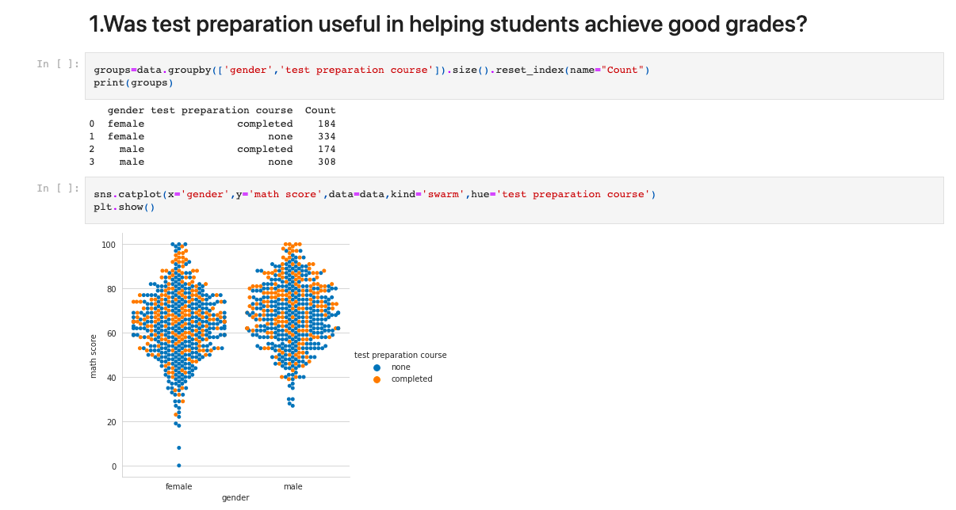

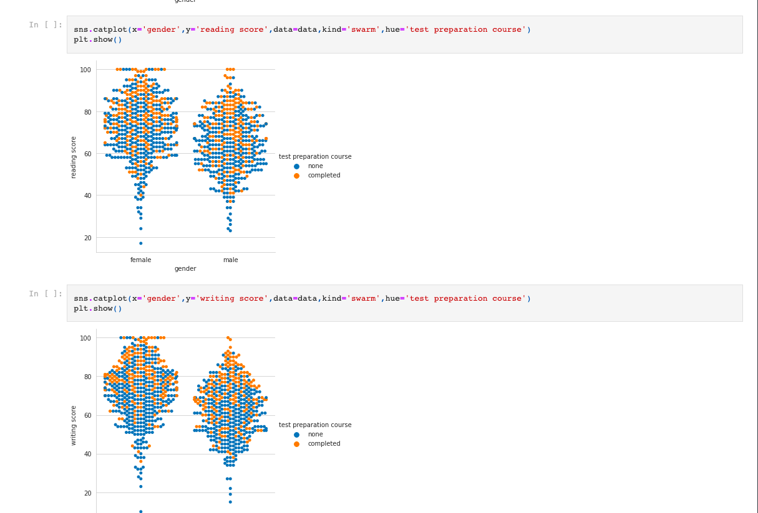

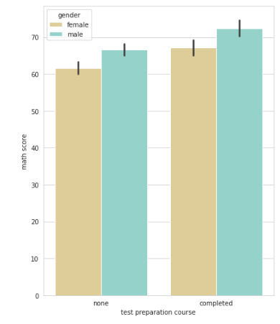

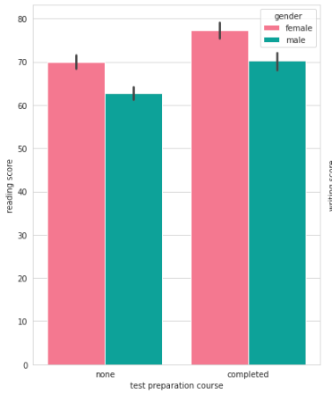

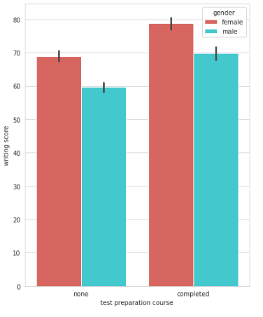

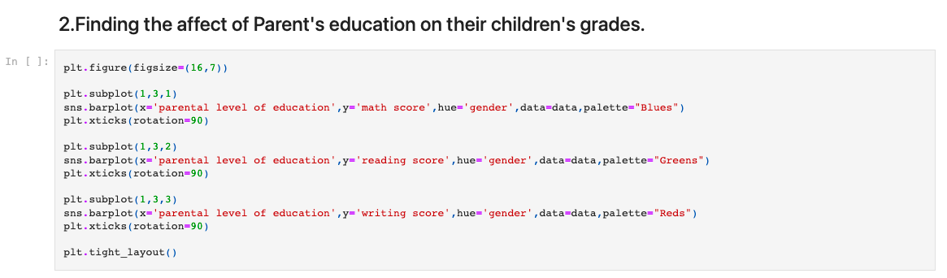

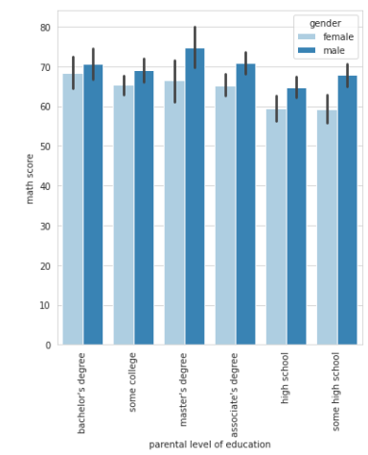

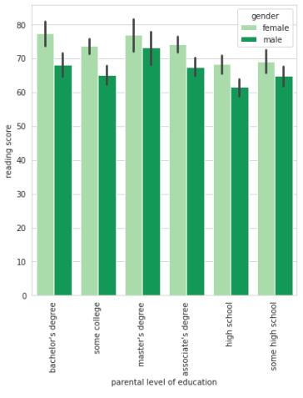

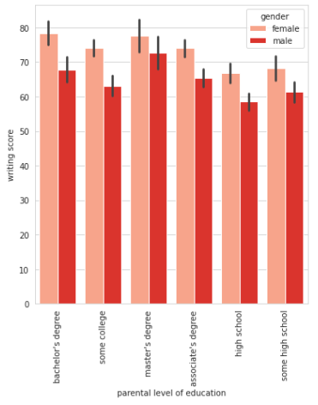

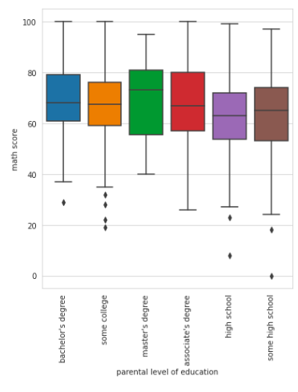

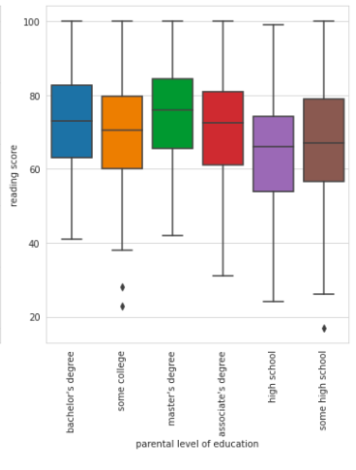

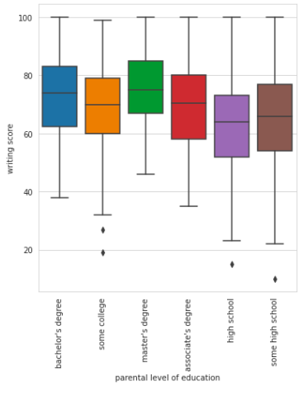

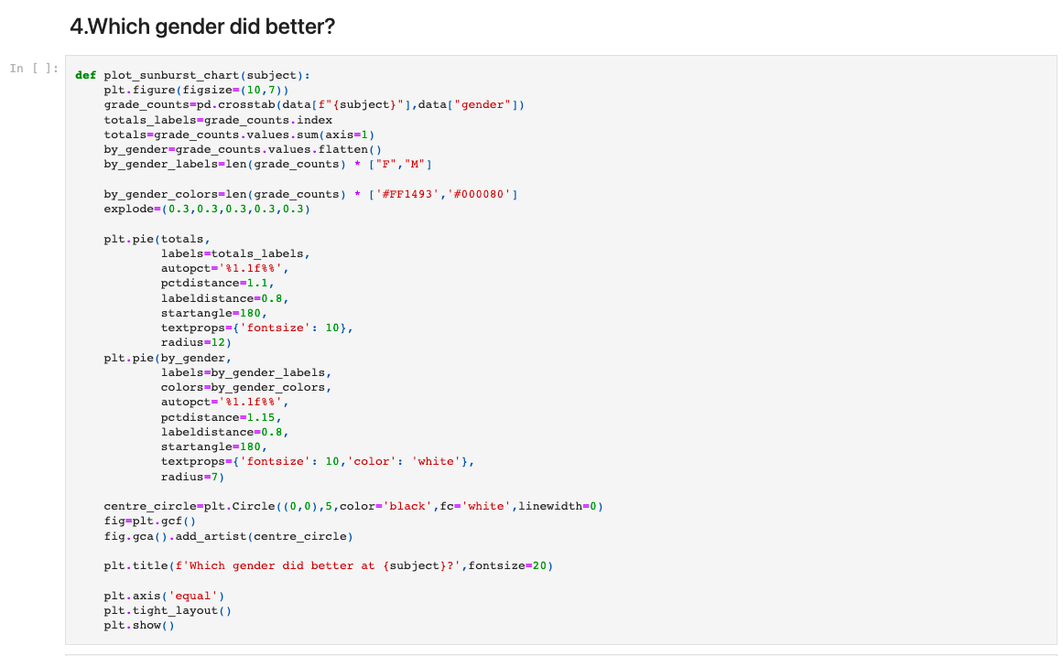

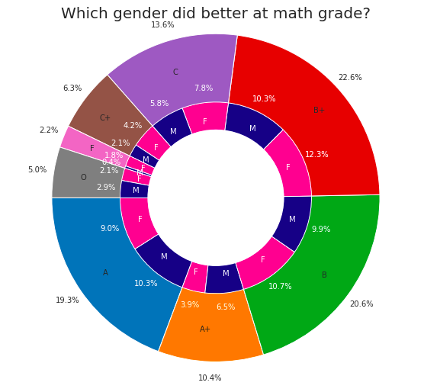

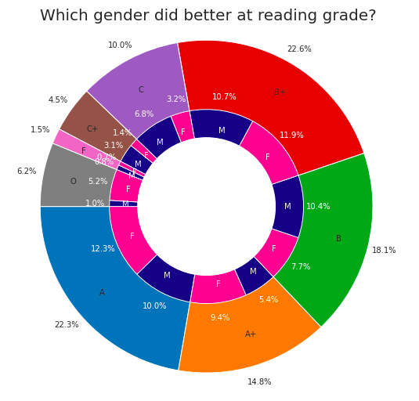

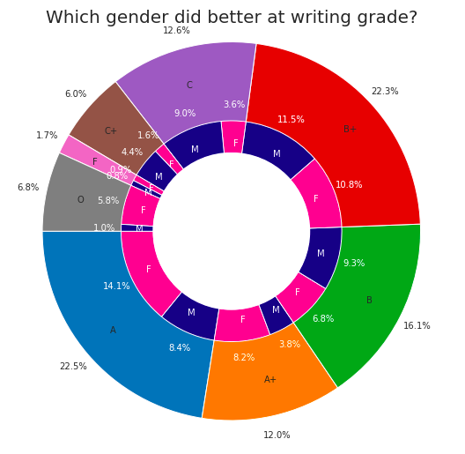

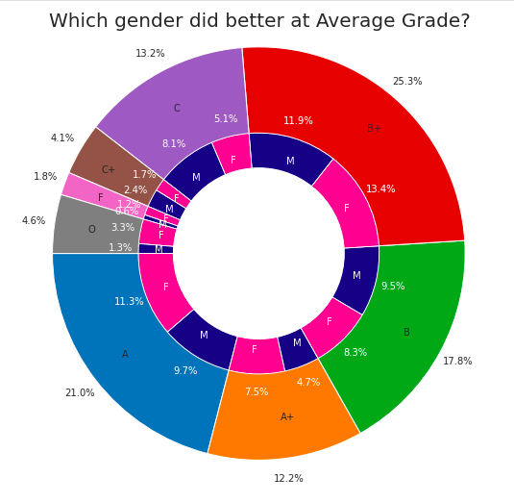

**TEAM MATES**

1. P.ADITHYA (RA1911027010003)
2. PUJAN DEBDAS (RA1911031010016)
3. UTKARSH SINHA (RA1911003010521)
4. VATSAL GUPTA (RA1911030010133)